Lab Report

By: Jahmil Ally (501045419)

# Observations and Analysis

## Q2:

* To test invalid proportioned triangles, I added a line to assertFalse for area > 0 as the Heron’s value will be negative for invalid triangles.

## Q3:

* The compilation error was due to \d not having an escape character, which could easily be rectified with \\d as seen in RE.java.
* In Java, \d is a metacharacter used in regular expressions to match any digit (0-9).
* RETest1.java tests RE.java and results in all tests failing due to oversights in the necessity of the parenthesis, although the need for spaces was considered.

## Q7:

* By using the newval array, the test for the sum greater theory fails because of the negative values when paired with a positive value. To rectify this, I added an assumption assumeTrue(a > 0 && b > 0) in MTHTheoryTest2 to assume all positive values for a and b.
* When I ran the tests with the final dataset, the sum greater theory failed because when the integer max value is summed with another value, it just results in the same integer max value, failing the test as b + a = a.

# Appendix:

## Q1:

### ArrayMult.java

### ArrayMultTest.java

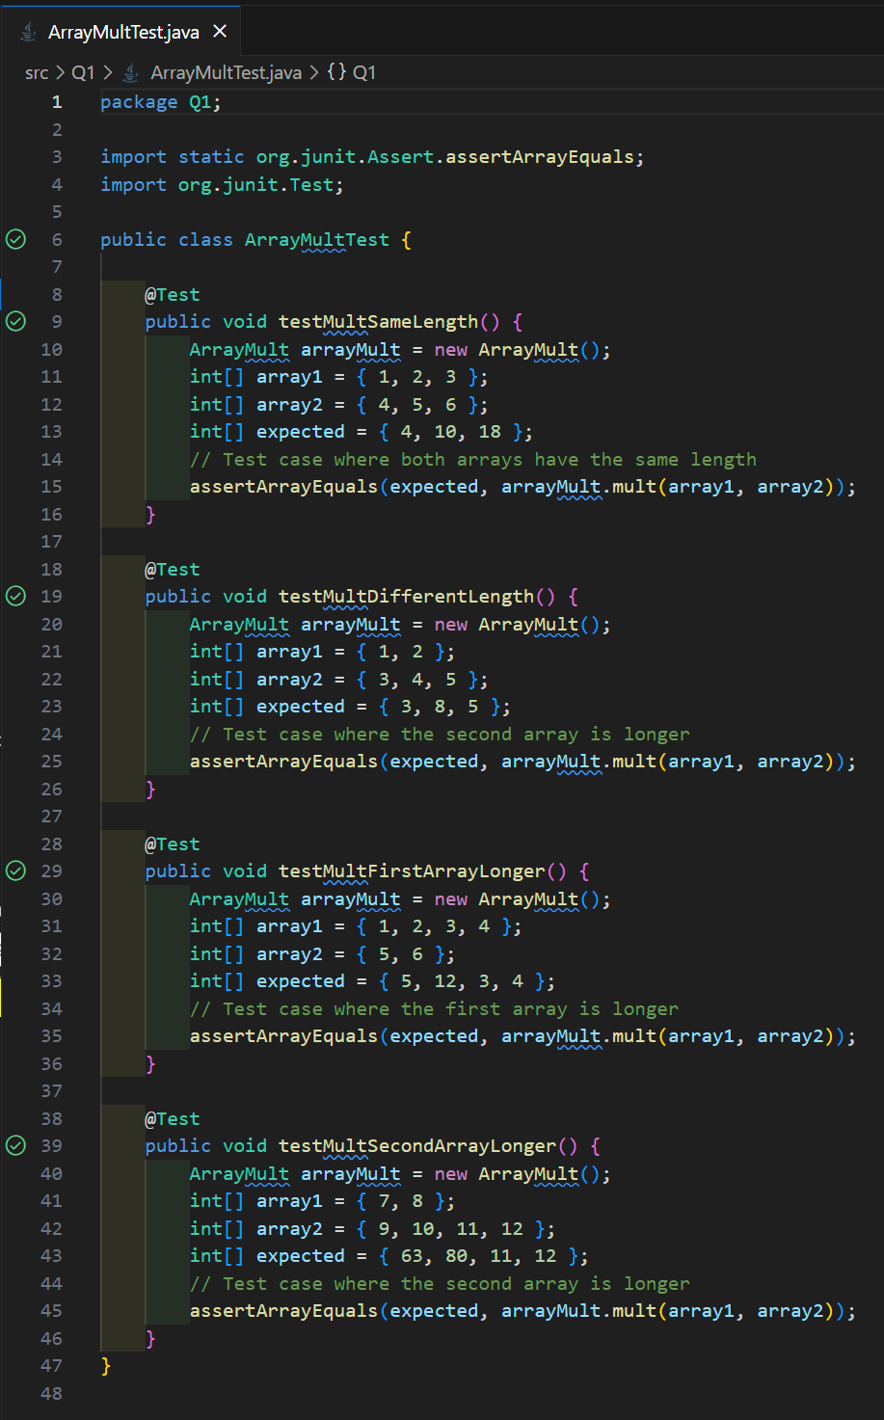

## Q2:

### Triangle.java

### TriangleTest.java

## Q3:

### RE.java

### RE2.java

### RE3.java

### RETest1.java

### RETest2.java

### RETest3.java

## Q4:

### testSuite.java

## Q5:

### Fibonacci.java

### FibonacciTest.java

## Q6:

### PNC.java

### PNCTest.java

## Q7:

### MTHTheory.java

### MTHTheoryTest1.java

### MTHTheoryTest2.java

### MTHTheoryTest3.java

## Q8:

### FibTheoryTest.java

### PNCTheoryTest.java

